Promoters have both great interest in the effort and the power to help make it successful (or to derail it.
Defenders have a vested interest and can voice their support in the community but have little actual power to influence the effort in any way.
Latents have no particular interest or involvement in the effort, but have the power to influence it greatly if they become interested.
Apathetics have little interest and little power, and may not even know the effort exists
Chapter 7. Encouraging Involvement in Community Work | Section 8. Identifying and Analyzing Stakeholders and Their Interests | Main Section | Community Tool Box (ku.edu)
Retrieved May 23, 2024
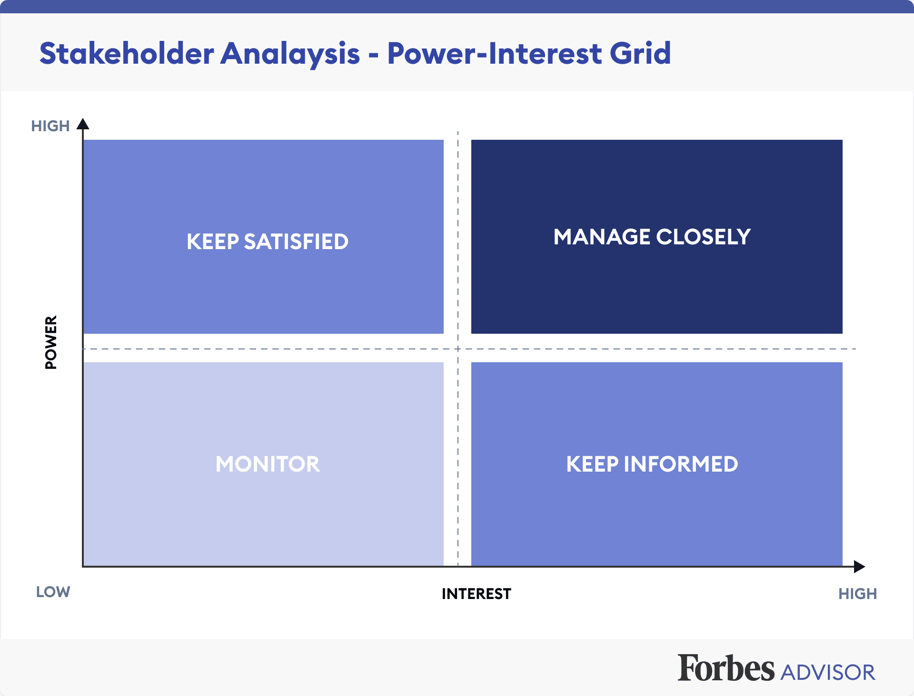

https://www.forbes.com/advisor/business/what-is-stakeholder-analysis/ Retrieved May 23 2024

