Fundamentals of Vascular Surgery:
Task Guidelines and Detailed Instructions
Scoring Information:

These three tasks are intended to assess a trainee’s readiness to perform basic open vascular techniques and should be able to be passed by the end of the third year of an integrated vascular residency. The instructions detailed here represent the key steps that should be performed to successfully complete the task, as well as the hard stops by which a trainee may fail the task. Each is intended to be timed as this has shown to be crucial in differentiating practice ready performance. While there are certain to be differences in technique while performing these tasks, the provided guidelines should be followed in the interest of uniformity and standardized evaluation. These tasks can also form the foundation of a vascular skills curriculum in both vascular and general surgery programs. To that end, the scoresheet provided allows for both formative (skills score) and summative (summary rating) feedback for evaluation. When used for teaching as well as for evaluation these tasks can be a robust tool for instruction of the vascular trainee.

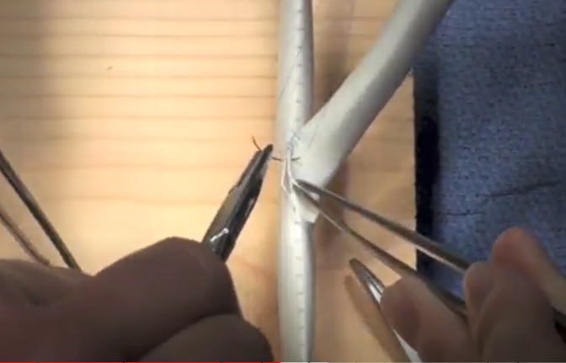
Task 1: End-to-side anastomosis
Maximum time limit: 20min
Equipment needed:
- Castro-viejo needle driver
- Fine forceps (x2)
- Hemostats (x4)
- Scissors
- #11 blade
- Suture board with clips
- 8mm PTFE graft
- 5-0 Prolene C-1 (x2)
Steps:
Place graft under tension in the clips on the suture board provided. Make an arteriotomy with a #11 blade and extend incision for six (6) blue markings. Bevel the second piece of graft to match the arteriotomy in length. Place heel stitch and tie down with three knots. Begin suturing the operator’s side and continue to the halfway point. Flip the board around and suture the other side in a similar manner. Space sutures evenly, having the assistant evert the edges. Stop when the side is 50% completed. Place the toe stitch and tie it down with three knots. Continue sewing the side closest to the operator, then tie the working end to the first stitch to complete the side. Flip the board around and complete the anastomosis.

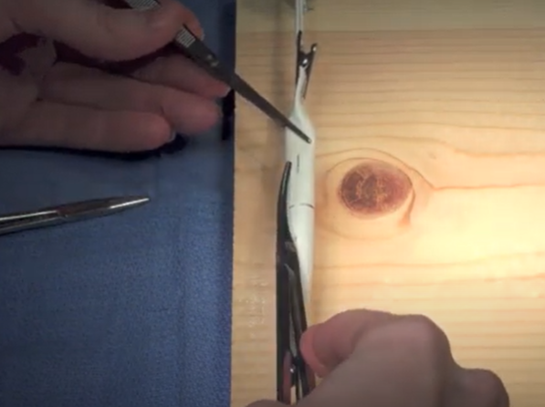
Task 2: Patch angioplasty
Maximum time limit: 20 min
Equipment needed:
- Castro-viejo needle driver
- Fine forceps (x2)
- Hemostats (x4)
- Scissors
- #11 blade
- Suture board with clips
- 10mm PTFE (with hash marks)
- 5-0 Prolene C-1 (x2)
Steps:
Stretch the graft and place it under tension. Begin arteriotomy with a #11 blade then cut an ellipse out of the graft, bisecting the stamped marks. Use the excised portion of graft as a patch. Suture one corner of the patch to the graft and tie it down with three knots. Begin sewing the side closest to the operator, continuing to the hashmark. Flip the board around and suture the other side in a similar fashion. Start a second suture at the opposite corner and continue suturing on the side closest to the operator until the previous stitch is reached. Flip the board and continue on the other side to complete the final quadrant of the patch. Tie the two sutures together to complete the anastomosis.

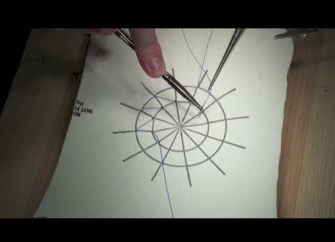
Task 3: Clockface suturing
Maximum time limit: 5 min
Equipment needed:
- Castro-viejo or Ryder needle driver
- Fine forceps
- Acrylic tube with clamps
- 10cm x 10cm x 0.5mm thick PTFE square (or substitute) stamped with clockface marks
- 3-0 Prolene SH (x1)
Steps:
Stretch the PTFE material between clamps in the acrylic tube. Begin at 6 o’clock on the clockface with the needle entering at the intersection of the linear ray and the inner circle, and exiting at the outer circle. Continue in a clockwise fashion, precisely placing the needle on the stamped line. Do not turn the model; suture backhanded when appropriate. Finish at the 5 o’clock position.

Schmiederer IS, Kearse LE, Korndorffer JR Jr, Lee E, Sgroi MD, Lee JT. Validity Evidence for Vascular Skills Assessment: The Feasibility of Fundamentals of Vascular Surgery in General Surgery Residency. J Surg Educ. 2021;78(6):e201-e209. doi:10.1016/j.jsurg.2021.07.009
Sheahan, Malachi & Lalani, Alykhan & Lee, Jason & Shames, Murray & Rigberg, David & Cass, Bryan & Sheahan, Claudie & Bismuth, Jean. (2020). The Fundamentals of Vascular Surgery: When Do Vascular Trainees Achieve Basic Open Surgical Competency?. Journal of Vascular Surgery. 72. e24-e25. 10.1016/j.jvs.2020.04.050.

