Links to FVS videos:
End-to-side anastomosis: https://www.youtube.com/watch?v=JzWJYVqa-4o 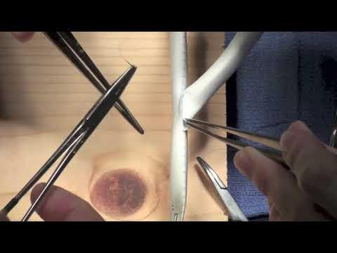
Patch Angioplasty: https://www.youtube.com/watch?v=BSIwJAi4cHs
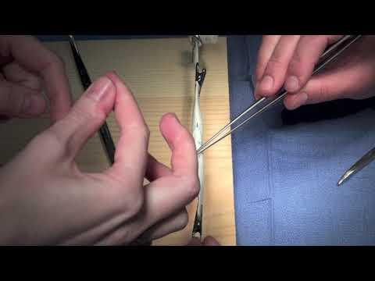
Clock Face Suturing: https://www.youtube.com/watch?v=X7Cjndz-znU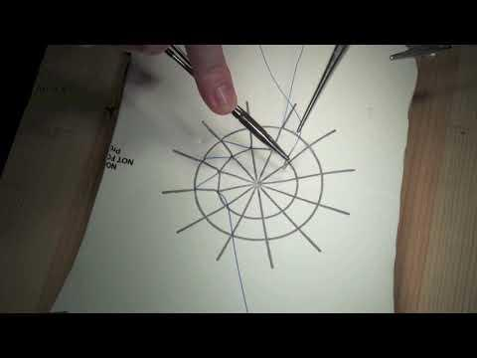

Dr. Sheehan APDVS talk with research background: https://www.youtube.com/watch?v=XhQL_aYjX-A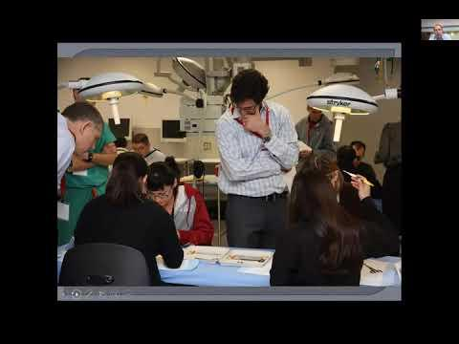
Dr. Sheehan APDVS talk with implementation: https://youtu.be/yBhzAH8Ou9s